JULIE ANN ALLENDER, Ed. D.
Licensed Psychologist
1111 S Tyler Ave Loveland CO 80537-8056
719-544-0018, C: 215-806-8338

Authorization to use and disclose protected health information
I. I am completing this form to allow the use and sharing of protected health information about
Printed name: Date of Birth:
2. I authorize this person or organization

3a. To use or disclose the following information:
Q Inpatient or outpatient treatment records for physical and or psychological, psychiatric, or emotional illness or drug and/or alcohol abuse. Admission and discharge summaries
Psychological or psychiatric evaluation(s), reports, assessments, treatment notes, summaries, or other documents with diagnoses, prognoses, recommendations, or testing records, and behavioral observations or checklists completed by any staff member or the patient, or similar documents.
Treatment, recovery, rehabilitation, aftercare plans and Other similar plans.
Social, family, educational, and vocational histories Social work assessments and plans
Progress, nursing, case or similar notes.
Evaluations and reports of consultants
Information about how the patient's condition(s) affects or has affected his or her ability to work, and to complete tasks or activities of daily living.
Q Vocational evaluations and reports
Billing records
Q Academic and educational records, including achievement and other test results, reports of teachers' observations, and all other school or special education documents.
HIV-related information and drug and alcohol information contained in these records will be released under this authorization unless indicated here Do not release. a Complete copy of the medical record.
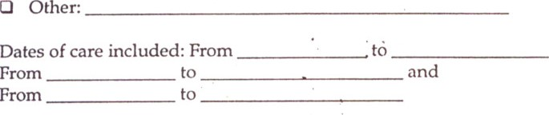and
3b.
4. To this person or organization
5.
The
the
following
purposes:

- I understand and agree that this Authorization will be valid and in effect until
[Enter a date or event upon which this
Authorization expires.] I understand that after that date or event, no more of this information can be used or released to the person or organization unless I sign a new Authorization like this one.
- I understand that I can revoke or cancel this authorization at any time by sending a letter to the Privacy Officer of the organization listed above and which is to supply this information. If I do this, it will prevent any releases after the date it is received but can not change the fact that some information may have been sent or shared before that date.
- I understand that I do not have to sign this authorization and that my refusal to sign will not affect my abilities to obtain treatment from the professional or facility listed at number 4 above, nor will it affect my eligibility for benefits.
- I understand that I may inspect and have a copy of the health information described in this authorization.
- I understand that if the person or entity that receives the information is not a health care provider or health plan covered by federal privacy regulations, the information described above may be redisclosed and no longer protected by those regulations.
Il. I understand that this professional or facility will receive compensation for the use or disclosure of my health information The arrangement has been explained to me and I understand and accept it.
Does not apply
- I affirm that everything in this form that was not clear to me has been explained and I believe I now understand all of it.
- Signature of client or his or her personal representative Date

Printed name of client or personal representative Relationship to the client

Description of personal representative's authority
- I acknowledge that I received a copy of this completed form
- I, a mental health professional, have discussed the issues above with the client and/or his personal representative. My observations of his or her behavior and responses give me no reason to believe that this person is not fully competent to give informed and willing consent

Signature of professional Printed name of professional Date
Copyright 2003 by Edward Zuckerman, www.hipaahelp.info

21

